Test Log:
- Power consumption of wheel motors
- Wheel speed and direction control
- Wheel encoder set up

Power consumption of wheel motors
Objective: Measure power consumption of 4 wheel motors for a training session of 30 minutes.
Items required for testing:
- 2x 127mm mecanum wheels assemblies
- 1x 10Amp 7V-35V SmartDrive DC Motor Driver (2 Channels)
- 24V 5A power supply
- 1x Arduino Uno
- Wooden test rig
Steps:
- Mount 2 wheels on the wooden test rig
- Connect motor wiring to motor driver and Arduino in the following configuration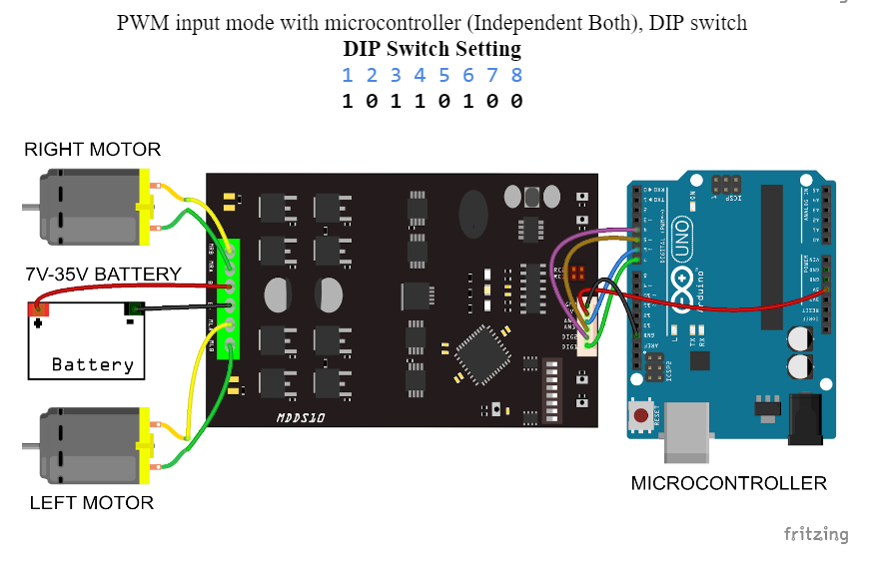
- Upload test code into Arduino. Test code commands wheels to move the test rig in a loop forward at full speed for 1s, stop for 0.5s, move backwards at full speed for 1s.
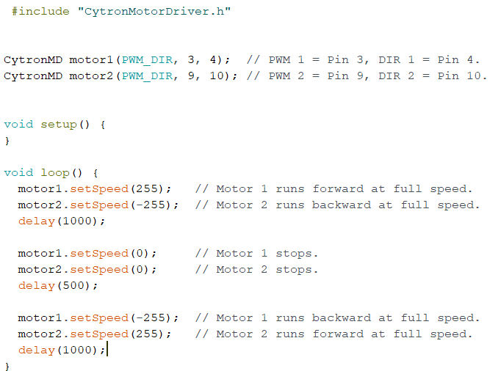
- Connect 24V power supply to the wheels through the motor driver for 10 minutes. Record the maximum current value used through the power supply.
- Power consumption of 4 wheel motors for a training session of 30 minutes will be the recorded power consumption (P=VI, V = 24V) multiplied by 2 (4 motors in total).
Calculations:
- The given specification of the maximum speed of the wheels is 440rpm. With a wheel diameter of 127mm, the achievable linear speed is 2.926m/s.
- We will use a case of a boxer side stepping the robot as a benchmark for the speed required of the robot. We will take a sidestep distance to be 40cm, with reference to the side of the wheelbase that is modelled after a human’s shoulder width. The median reaction time of a human is 0.273s. The robot should match the boxer’s calculated speed of 1.465m/s.
- As the above speed falls in the range of the achievable speed of the wheels, this wheel set is suitable for the robot.
Results:
(Test rig set up)
- The estimated mass of the robot is around 40kg. Given that the test rig is built on two mecanum wheels, we will load the test rig up to 20kg.
- At 10% of max speed, the two wheel motors draw up to 0.22A total under 20kg load.
- At 31% of max speed, the two wheel motors draw up to 1.26A total under 10kg load.
- At 31% of max speed, the two wheel motors draw up to 1.37A total under 20kg load.
- The rated current of one wheel motor is 2.7A, hence there is reason to conclude that the wheel motors will not draw beyond 2.7A under 20kg load at the required linear speed of 1.465m/s.
Wheel base testing
- At 50% of the max speed, the four wheel base draws up to 3.35A under 50kg load.
  - As the speed of 1.46 falls in the range of the achievable speed of the wheels, this wheel set is suitable for the robot.

Wheel speed and direction control
Objective: Establish control of the speed and direction of the robot using the mecanum wheels. It should be able to move in every direction, rotate and vary speed.
Items required for testing:
- 4x 127mm mecanum wheels assemblies
- 2x 10Amp 7V-35V SmartDrive DC Motor Driver (2 Channels)
- 24V 5A power supply
- 1x Arduino Mega
- Steel wheel base
Steps:
- Mount 4 wheels on the steel wheel base
- Connect motor wiring to motor driver and Arduino in the following configuration
- Upload test code into Arduino. Test code commands wheels to move the test rig in a loop forward at full speed in every direction.
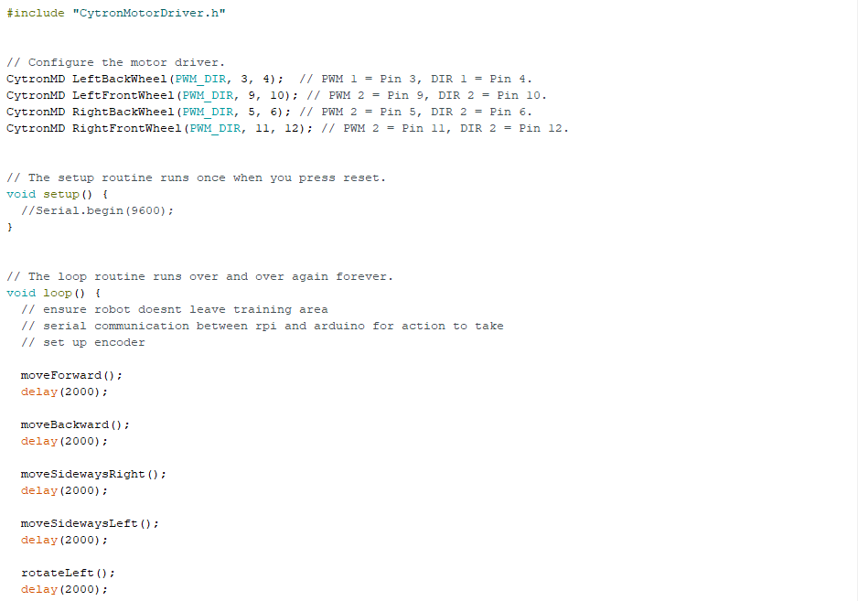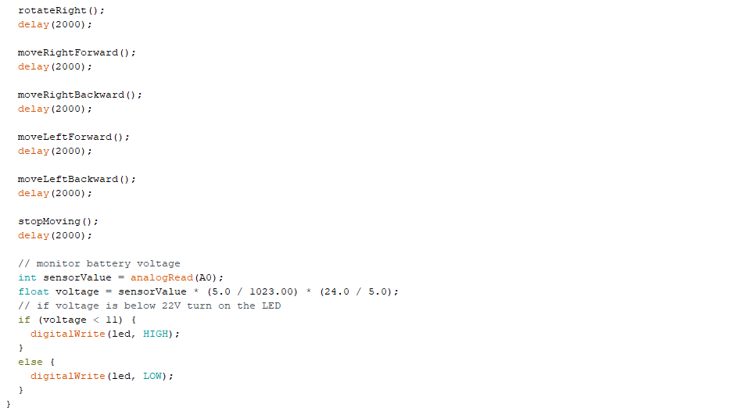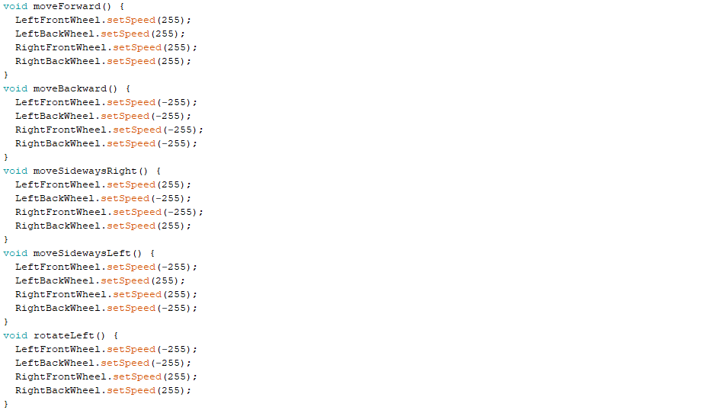
- Connect 24V batteries to the wheels through the motor driver.
- Repeat for different motor speeds.
Wheel encoder set up
Objective: Achieve instantaneous updates of position of robot based on encoder readings of all 4 motors.
Items required for testing:
- 4x 127mm mecanum wheels assemblies
- 2x 10Amp 7V-35V SmartDrive DC Motor Driver (2 Channels)
- 24V 5A power supply
- 1x Arduino Mega
- Steel wheel base
Steps:
- Connect hall sensor Vcc to Arduino 5V supply and hall sensor GND to Arduino GND
- Connect hall sensor A and B to corresponding digital pins as per code in encoder_testing
- Upload encoder_testing code to Arduino
- Physically turn the wheel in one direction one full revolution, ensuring that position and direction are accurate
- Repeat for different wheel rotations.

